Figures & Tables
Figure 1:
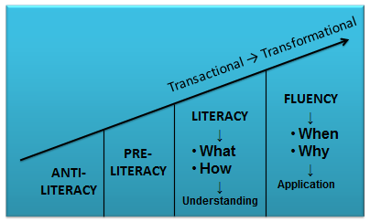

Figure 2:
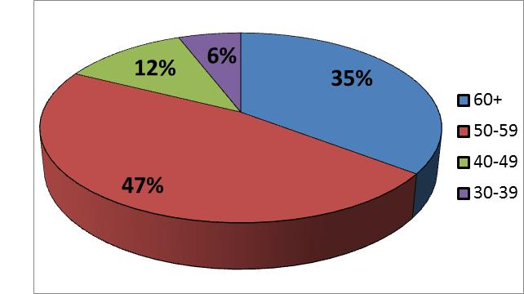

Figure 3:
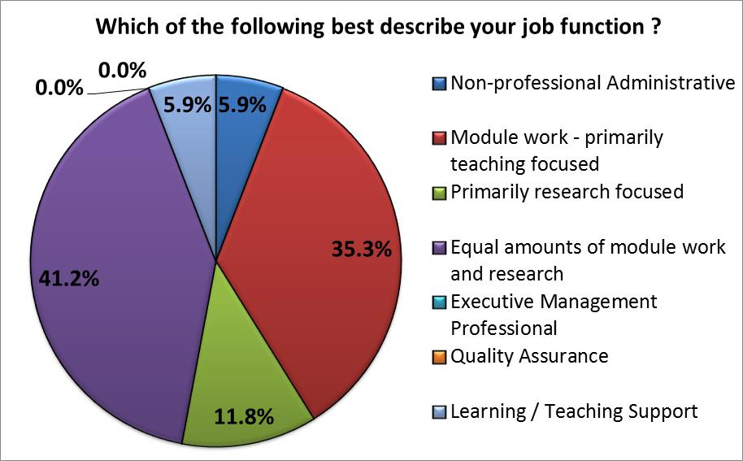

Figure 4:
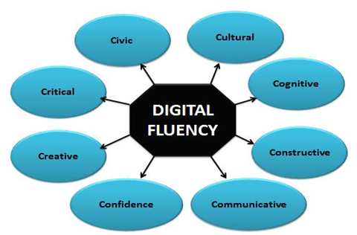

Table 1:
Answer options | Strongly agree & Agree | Strongly disagree & Disagree | Not applicable | Response Count
 | f | f | f | n
Unisa allows us as lecturers to freely experiment with different software programs and applications to enhance our teaching | 10 | 3 | 1 | 14
There is a lot of red-tape before one can use alternative programs and applications for teaching | 5 | 7 | 1 | 13
I have enough time at work to experiment with alternative programs and applications for teaching | 4 | 9 | 1 | 14
Unisa's policies are not enabling lecturers to use alternative programs and applications for teaching | 5 | 8 | 1 | 14
Unisa supports the use of alternative programs and applications for teaching | 11 | 1 | 1 | 13
ICT cannot provide support for us to use alternative programs and applications for teaching | 7 | 5 | 1 | 13

Table 2:
Question: In my personal and social life I do the following (tick all that apply):
 | Percentage | Frequency  (f =)
Use social networking websites (e.g. Facebook) | 46.7% | 7
Download podcasts | 20.0% | 3
Use instant messaging or chat (e.g. MSN, iChat, MXit, WhatsApp) | 86.7% | 13
Video-chat or video-conference (e.g. Skype, ooVoo) | 33.3% | 5
YouTube (watch and/or download) | 66.7% | 10
Upload video or photo content onto the internet | 40.0% | 6
Use on-demand video (e.g. iPlayer, 4OD) | 0.0% | 0
Use advanced functions on my mobile phone (e.g. Mobile TV, Web browser, GPS or email) | 46.7% | 7
Participate in online discussion groups or chat rooms | 40.0% | 6
Take part in an online community, e.g. a “virtual world” such as Second Life | 13.3% | 2
Blogging (e.g. wordpress, blogspot) | 6.7% | 1
Micro-blogging (e.g. Twitter or similar) | 6.7% | 1
ePortfolio (e.g. LinkedIn) | 20.0% | 3
Google Hangout | 0.0% | 0
Google Docs | 13.3% | 2
Cloud-storage (Dropbox, Mega) | 20.0% | 3
In addition to download and upload of media or content, I can also adapt media | 13.3% | 2

Table 3
Answer options | Percentage | Frequency  (f =)
LMS (learning management system) (e.g. Blackboard, Moodle, etc.) | 52.9% | 9
Creating a pdf | 17.6% | 3
Using Podcasts | 47.1% | 8
Creating Podcasts | 52.9% | 9
Using video-clips | 35.3% | 6
Creating video-clips | 70.6% | 12
Using URLs and hyperlinks to websites | 47.1% | 8
Using computer software such as PowerPoint, Word, Excel, Outlook (e-mail), etc. | 17.6% | 3
Effectively browsing the Internet | 17.6% | 3
Using social media (Facebook, Twitter, etc.) | 58.8% | 10

Table 4
Answer options | I have not used this / can’t use this | I’m not that confident and need help | I can do this quite well | I believe I am HIGHLY confident/ competent/ proficient in this
 | f | f | f | f
I have a blog, edit my blog | 10 | 3 | 1 | 0
Collaborating online (such as participating in a forum, contributing to a wiki, group work online) | 5 | 5 | 3 | 1
Create my own wiki site/page, edit a wiki, invite others to edit my wiki | 10 | 3 | 1 | 0
Social bookmarking/sharing (such as delicious, CiteULike) | 10 | 3 | 1 | 0
Flickr (or similar alternative) – collating, and sharing photos | 10 | 3 | 1 | 0
File storage and sharing (such as Dropbox) | 1 | 7 | 4 | 2
FaceBook – communicating with & finding friends, upload images, chat | 7 | 1 | 1 | 5
FaceBook – aware of how to use the security settings | 7 | 1 | 3 | 3
I am on Twitter - I follow people, tweet, use hash tags | 11 | 2 | 0 | 1
Instant messenger systems - send messages, audio/video chat, group chat, add friends, block people | 4 | 3 | 5 | 2
Professional networking sites – such as LinkedIn | 4 | 2 | 5 | 3

Table 5
Answer Options | Percentage | Frequency  (f =)
I can teach others in my Department | 6.3% | 1
I am comfortable with tools and applications on our university's LMS/Learning Management System (e.g. Official LMS, Blackboard, Moodle, etc.) and other programs | 6.3% | 1
I can help myself but can do with extra assistance / help | 50.0% | 8
I can use a few of the tools on our LMS | 31.3% | 5
I am in serious need of assistance | 6.3% | 1

Table 6
Answer options | I have not used this/can’t use this | I’m not that confident and need help | I can do this quite well | I believe I am HIGHLY confident/competent/ proficient in this | N =
 | f | f | f | f
All the main features of Word | 0 | 0 | 5 | 9 | 14
All the main features of PowerPoint | 0 | 2 | 6 | 6 | 14
All the main features of Excel | 0 | 7 | 6 | 1 | 14
Install software on a PC | 4 | 1 | 9 | 0 | 14
Use Antivirus software to identify and sort out a computer virus | 3 | 3 | 6 | 2 | 14
Mac/PC literate – cross platform skills. I can use both platforms | 9 | 2 | 3 | 0 | 14
USB sticks/memory cards – storing and transferring information | 0 | 1 | 4 | 9 | 14
Using email to send messages and attachments | 0 | 0 | 3 | 11 | 14
Printing documents/information | 0 | 0 | 3 | 11 | 14
Accessing the Internet through Wi-Fi or network cabling | 0 | 0 | 7 | 7 | 14
Browsing and navigating on the Internet | 0 | 0 | 7 | 7 | 14
Watching videos and listening to music on the Internet | 0 | 2 | 5 | 6 | 13
Registering and making bookings on the Internet | 1 | 1 | 5 | 7 | 14
Text messaging (SMS) and e-mails via a mobile device (e.g. Smartphone or tablet) | 0 | 0 | 4 | 10 | 14

Table 7
Answer Options | I have not used this/can’t use this | I’m not that confident and need help | I can do this quite well | I believe I am HIGHLY confident/competent/ proficient in this | n =
 | f | f | f | f | n
Use myUnisa (the VLMS) | 0 | 1 | 6 | 5 | 12
Understanding and considering copyright when using or uploading online content | 0 | 5 | 6 | 2 | 13
Information seeking using search terms to find information (Google) | 0 | 1 | 7 | 5 | 13
I can refine searches using Boolean searching techniques | 2 | 5 | 5 | 1 | 13
Using information for own use (comparing, collating and evaluating a range of information sources) | 2 | 4 | 4 | 3 | 13
I can use an online library catalogue e.g. the university’s library system to find formal journals/academic papers/books/e-books | 0 | 2 | 6 | 5 | 13
Finding official newspaper archives for educational use | 1 | 4 | 5 | 3 | 13
Evaluate whether a web source is (valid/reliable/trustworthy/authentic/credible) | 3 | 5 | 4 | 0 | 12
I know how to reference information I found online (e.g. journal articles, e-books, websites) | 0 | 2 | 8 | 3 | 13
Searching subscribed university databases (such as Infotrac, emerald, InTute, LexisNexis) | 2 | 2 | 8 | 1 | 13
Reading e-books | 0 | 2 | 7 | 4 | 13
Searching Google Scholar | 0 | 1 | 7 | 5 | 13

