TURNING POINT IN CHRISTIANITY: EASTERN EUROPE IN THE LATE 20TH CENTURY

Religion has reasserted itself as an important part of individual and national identity in Eastern European countries. This happened where communist regimes once repressed religious worship and promoted atheism.

ABSTRACT:
Ten years before the collapse of communism, there were warning signs that the Soviet Union’s economy was crippled. Soviet authorities control and influence the Russian Orthodox Church and jailed leaders of the church in all Eastern European countries.
The fall of the Berlin wall created a turning point in Christianity in 1989. More than 8,000 Russian Orthodox Churches were reopened between 1990 and 1995. The Nineties could be described as a time of hope of religious revival in Eastern Europe. In this paradigm shift freedom of religion – becoming officially recognized as a basic human right and a multitude of denominations became free to compete for followers. Prague Cardinal Miroslav VII ministered clandestinely to Catholics while officially working as a window-washer during communist rule. He was known by the people as the generous pastor. After the valet revolution, he became Bishop and later Cardinal in the Czech Republic.
In many Eastern European countries, religion and national identity are closely entwined. According to the Pew’s Research Centre report on Christianity in Eastern Europe there were a sustainable increase from the early 1990’s until 2017 in religious activities. The fall of the Berlin wall had a great influence on South Africa. It helped South Africa in its democratic process. The once dominated Neo-Calvinistic control of society were replaced by a new paradigm of democratic freedom and an equal religious stance by the new government since 1994.

1. THE SOVIET ERA
For much of the Cold War, for the years after the Second World War, the West saw the Soviet Union as strong, still the nineteenth century Russian bear (Castleden 2006:568).
There were warning signs, ten years before the collapse, that the Soviet Union’s economy was crippled. The biggest warning sign was the Soviet Union’s huge debt. The invasion of Afghanistan by Russia in 1979, was the beginning of a long and expensive war that they had not foreseen. Economically it was disastrous. Internally Mikhail Gorbachev’s policies of glasnost (openness) and perestroika (restructuring) opened the door for change (New York Times 2007:523).
Maxwell (1988:v) stated glasnost is the willingness without fear to throw open long-shuttered windows on Soviet life. It is to release a natural force. Glasnost is one of the major democratic principles of the Socialist system. Soviet people have a real opportunity to express their opinion on any problem in public and political life (Aganbegyan 1988:5). Glasnost has been institutionalized as the indispensable condition of the democratic nature of the Socialist system.
Fallin (1988:285) said, one can’t speak democratization without glasnost and such glasnost, at that which would not be limited to members of the Communist Party alone. Glasnost also lead to an openness I international relations (Fallin 1988:292).
Glasnost means dialogues, and dialogues require a certain level of culture, tolerance and good will. Perestroika is a process to combine the achievements of the scientific-technological revolution and the planned economy, to bring action. Perestroika provides for priority development to the social sphere, meeting the demands of Soviet people for good living and working conditions, education, medical services and opportunities for recreation. It also focus on the spiritual and cultural enrichment of each individual and society as a whole. The ideological aspect of Perestroika is no less important. Perestroika entails society energetically getting rid of distortions of Soviet morality; it means persistent realization of the principles of social justice; the rise of honest, good-quality work and the fall of wage-levelling (Aganbegyan 1988:1).
Perestroika is a new economic strategy fir Russia’s economic development. It means going over a new quality of growth. Economic growth will be supported the road of the intensification, facilitated by the breakthrough of technical revolution. The old administrative system must be dismantled and replaced by a fundamentally new and comprehensive system for managing the overall economy. Economic methods of investment planning, proper accounting of all the financial transactions, market developments and stronger incentives for more productive work, will lead to a fuller integration in the world economy.
According to Aganbegyan (1988:73) will the new strategy require reconceptualization of changes that will be leading to qualitative changes to the base of a diversified economic life. Communism under Soviet Union power was known for its central control. They used their power to control every aspect of society.
There were no aspects of private lives. The Soviet Union took over control on every level of the citizens’ existence. One was not supposed to think anymore. The police force and army have taken absolute responsibility. But on the positive side the state provided a lot of social services for free: education, health etc.
Unemployment was a crime and missing a day’s work could lead to six months of corrective labor. It was also a crime to be an entrepreneur or work for oneself. The state employed everybody.
Lenin demanded a policy of “militant atheism” and wanted to systematically stamp out religion wherever it could be found. Atheism was set up as the scientific truth, and churches were torn down. In their place, the Soviets built edifices that could be called churches themselves. Even the seven day work week was a problem. Lenin didn’t like the idea of people measuring time based on the Biblical story of creation and of taking the Lord’s Day off, so he made his own calendar (www. bizarre-ways-the-soviet-union-controlled-its-people/).
Lenin frequently quoted Marx that religion is the opium of the people (www.en.m.wikipedia.org/wiki/Religion in the Soviet Union).
As for the Russian Orthodox Church, Soviet authorities sought to control it and, in times of national crisis, to exploit it for the regime’s own purposes, but the ultimate goal was to eliminate it. During the first five years of Soviet power, the new regime executed 28 Russian orthodox bishops and 1,200 priest. Many others were imprisoned. Under Brezhnev, there were 7,000 active Russian orthodox churches in 1975. They jailed the leaders of the church. Their place was taken by docile clergy, who were obedient to the state. The church was also infiltrated by KGB agents and the church was a useful tool to the regime (www.countrystudies.us./russia/38.htm ).
In the mid 1980’s, Russian Orthodox churches were reduced to an all-time low of 3,000 churches.
(Video) https://youtu.be/8feVMryQgaw

2. THE PARADIGM SHIFT:
The fall of the Berlin wall created a turning point in Christianity in 1989.
This lead to a paradigm shift in Russia and Eastern Europe. A paradigm is a set of rules and regulations (written or unwritten) that does two things:
1. It establishes or defines boundaries; and
2. It tells you how to behave inside the boundaries in order to be successful (Barker 1993:32).
The Soviet Union set up the paradigm of Communism in Eastern Europe. With the fall of the Berlin Wall this paradigm had shifted. Joel Barker (1993:32) stated that when a paradigm shifts, there is a change to a new game, a new set of rules.
Planyi (1958:288) stated: As long as one lives and thinks within the pattern of a given paradigm, that paradigm provides one with a plausibility structure according to which all reality is interpreted. That paradigm may be a scientific worldview or a religion or an ideology and in each case the conceptual frame work has almost all embracing interpretative powers.

President Gorbachev used his glasnost policy to impose new laws in 1989 that specified the churches’ right to hold private property. In 1990 the Soviet ligature passed a new law on religious freedom (www.countrystudies.us./russia/38.htm ).
More than 8,000 Russian Orthodox Churches were reopened between 1990 – 1995. In Moscow the state also erected the new Christ the Soviour Cathedral at an expense of US $300 million. The Russian Orthodox Church’s social services expanded considerably. A new wave of catechism and religious education was implemented. New enrollment of priests was a priority and a chaplain service was introduced in the Department of Defense. Patriarch Aleksiy, head of the Russian Orthodox Church, officiated at President Yeltsin’s inauguration in 1991 (www.countrystudies.us./russia/38.htm ).

Sannikov (1996:1) describes the beginning of the Nineties as a time of hope for religious revival in Eastern Europe. Hundreds of missionary organizations of the West actively work in Eastern Europe. It was the era of evangelistic crusades and it was hosted over a lot of the major cities in Eastern Europe. In this Evangelical crusades people made a commitment to accept Christ. But the Evangelical Christians remains under 5 % of the population in most Eastern European countries (Sannikov 1996:1).
Borawik (2002:501) argues that the break-up of the Soviet Union brought a radical shift in Eastern Europe when the legal position of the churches changed dramatically, with the new governments recognizing freedom of religion as a basic human right. In Russia, Belarus and Ukraine, the number of those who declared their belief in God hiked immediately. In these countries there was also an adherence to the Orthodox tradition. Some social elements of Communism that fell away was taken over and administrated by the orthodox churches. Old age homes, orphanages, shelters and feeding schemes could be mentioned. Norris & Inglehart (2011:114) stated that the collapse of living standards and the disappearance of the welfare state after communism lead us to suspect a short term revival of religiosity in low- to moderate-income societies.
More vulnerable segments of the population such as elderly live on dwindling state pensions while facing hyperinflation in food and fuel costs. Widespread feelings of insecurity were also engendered by the sudden introduction of neo-liberal free markets, which produced severe recessions, throwing millions of public sector workers out of work and where household savings are threatened by hyperinflation (as in Azerbaijan and Belarus). Here was even more uncertainty where political stability and government leadership was undermined because of corruption and a banking crisis (Norris & Inglehart 2011:114).
The dissolution of the Soviet Union and the collapse of communism brought a radical change in the relationship between church and state throughout Eastern Europe. Religion was not destroyed but mostly discourage in most of these societies (Tomka 1998:229).
In this paradigm shift freedom of religion becoming officially recognized as a basic human right and a multitude of denominations became free to compete for followers.
In Eastern European, countries where churches were actively involved in resistance against the soviet regime and the struggle for independence, public religiosity continues to the relatively high. In Poland and the Czech Republic, for example the role of the Catholic Church in opposing the communist state and the Western orientation and organization links of Roman Catholics meant that the church maintained or even strengthened its role after independence. Polish Catholicism became associated with nationalism, freedom, human rights, and democracy (Norris & Inglehart 2011:118).
Norris & Inglehart (2011:112) stated that in Poland, Soviet-led attempts at repression of religion were contra-productive in the Communist era, leading to Polish people emphasizing their attachment to religion as a way to preserve their Polish identity.
According to Norris & Inglehart (2011:113) countries such as Turkmenistan, Kazakhstan and Uzbekistan in Central Asia experienced changes after the fall of Communism. These countries markedly lost ground during the 1990’s with economies characterized by large numbers of peasant farmers, faltering heavy manufacturing industries, structural underemployment, negative growth, poor basic healthcare, shrinking average life spans, social inequality and widespread poverty.
In Hungary the Evangelical Church made some inroads and became the fourth largest religious body. Its “prosperity gospel” had an extensive appeal among the Budapest middle class who were linked to the neo-liberal element in government (Berger 1999:48).

3. THE CZECH REPUBLIC:
In the Czech Republic Church leaders experienced huge constraints during the Communist era. Prague Cardinal Miroslav VII ministered clandestinely to Catholics while officially working as a window-washer during communist rule. He was known by the people as a generous pastor. After the valet revolution, he became bishop and later Cardinal. There was a practice in the Roman Catholic Church that priests and bishops were ordained underground because a lot of them were imprisoned or prosecuted since 1968 (Corley 1993:171).
In 1968 Russia invaded Czechoslovakia and made it a satellite of the Soviet Union. The valet revolution changed everything in Czechoslovakia and even after 1992 when the Chez Republic was formed. The Chez Republic had religious freedom but kept their suspicion against the Roman Catholic Church since they killed their church reformer Jan Huss in 1415. Economically the Czech Republic has been successfully integrated in the EU but secularization and individualism may be the root course for low church attendance.
The new constitution and other laws and policies led a new era of religious freedom in and in practice, the government generally enforced these protections. Religious affairs are the responsibility of the Department of Churches in the Ministry of Culture.
There was 32-state-recognized religious organizations. Religious organizations received $78 million annually from the government in 2010. This money was used to pay the salary of clergy, church administration and maintenance of church property (www.state.gov.czech republic).

4. IMPLICATION FOR TODAY:
Beyers (2013:21) stated that in a new paradigm the question arise whether religion can currently be seen as a private or public matter. If seen as something private, the question arises whether religion has any significance for society, and if it does, how should religion be defined if it is confined to a personal choice and practice by the individual? Or, is religion still regarded as visible in society and does it exert influence on society through social intervention (Beyers 2013:21).
Classical Secularization Theory largely based upon the works of the sociology’s founding fathers – Marx, Durkheim and Weber – linked the decline of religion with the advent of industrial society. As argued by Weber and later developed by sociologist of the 1960’s and 1970’s (Berger, Martin & Wilson), the development of western rationality made the world calculable, predictable and controllable in such a way that god and religion were no longer required in explanations of natural and social day-to-day general occurrences. Rational science, came also in conflict with religion, which rest on belief (Peréz-Nievas & Cordero 2010:3).
These two brands of Secularization Theory came under strong criticism from the 1990’s onwards Berger, later switched his position to deny secularization as an universal process and Chaves (1994) defined secularization “as the declining scope of religious authority” (Peréz-Nievas & Cordero 2010:3). There was clear and sharp increases in church attendance in Slovakia, Romania and Poland. Regards the importance of God, Eastern Europe shows clear religious revival including Hungary, but a slight decline in Czech Republic and Slovenia (Peréz-Nievas & Cordero 2010:6).
According to the European Values Survey (1980 – 2008) Eastern European were divided in two groups with regards to confidence in churches. There was a remarkable increase in the case of Romania while the increase was quite moderate in the case of the rest. Poland, the clearest example in other items, showed a clear loss of confidence in the church over a period of twenty years (Peréz-Nievas & Cordero 2010:6). A factor that influenced the decrease could be the solidarity the church showed twenty years earlier with the people against the Communism régime. European Catholicism gave more organic political responses to secularizing threats according to Peréz-Nievas & Cordero (2010:10). This might explain why the erosion of religion began later and was at a slower speed in Catholic Europe.
Peréz-Nievas & Cordero (2010:11) expect religiosity levels to be stronger among those groups of society who are more vulnerable to risks. Norris and Inglehart (2011:29) defended the modified version of the secularization thesis known as the existential security model. According to this theory, women, the unemployed and individuals with low incomes ill show higher levels of religious involvement than at the opposite extreme: men, individuals inserted in the labor force and/or enjoying high levels of income. Peréz-Nievas & Cordero (2010:11) reflects that married individuals showed higher levels of religiosity than individuals who remain single, across all types of societies.
Peréz-Nievas & Cordero (2010:16) use the European Values Survey (1980 – 2008) to divide the 18 countries in two blocks: countries which were former communist states versus countries that were not communist in the past. In all dimensions of religiosity (except in the degree of confidence in churches) former communist countries depart from levels of religiosity below their non-communist counterparts. Only with regard to confidence in churches, former communist countries present higher levels of religiosity than non-communist countries for the whole period. Former communist countries show levels of higher church attendance than non-communist past countries. Poland is a clear case of religious revival. There are also positive trends of religious revival in Romania, Slovakia and Bulgaria. In other Eastern European countries, there are also signs of increasing levels of religiosity but have little effect on other traditional measures such as church attendance (Peréz-Nievas & Cordero 2010:23).
One of the reasons why church attendance in Eastern Europe never hiked again, could be found in the following viewpoint. Berger (1967:33) refers to this as the “privatization of religion”. Religion is no longer a public matter, but a personal one. Sundermeier (1999:13) attests that the growth of new religious movements and the resurgence of fundamentalism and the esoteric merely prove that religion seeks new ways of expression; no longer institutionally, but privately.
According to Beyers (2013:6) religion is not static and under certain social conditions religious affiliation and religious form can change. Weber (1966:121,122) identifies the loss or change of political power as one factor what may change religion. When the privileged ruling classes loose political control or political influence, religion is determined to take on a salvific form.
In many Eastern European countries, religion and national identity are closely entwined: This is true in former communist states, such as the Russian Federation and Poland, where majorities say that being Orthodox or Catholic is important to being “truly Russian” or “truly Polish”.
Strong association, especially in Orthodox majority countries exist, between religion and national identity.

5. THE PEW RESEARCH CENTRE ON CHRISTIANITY IN EASTERN EUROPE:
According to the ‘The Economist’ (Erasmus 2017:2) the study of 18 countries by the Pew Research Centre, a think-tank based in Washington D.C., mostly shows huge majorities professing their adherence to Christianity in its locally dominant form. In this process that affiliation with loyalty to the nation and socially conservative views had been linked. The Catholic faith is professed by 75 % of the Lithuanians, 84 % of Croats and 87 % of Poles.
The Czechs are an exception, with one of the most secular profiles in Europe: some 72 % profess no religious affiliation (Erasmus 2017:2).
Pew’s editors found a neat way of summing up their findings. A British sociologist, Grace Davie, had once coined the phrase “believing without belonging” to describe the spirituality in Western Europe: they wanted a spiritual aspect in their lives but had little interest in joining a church of attending worship. Pew’s editors found that people linked faith with collective identity but only a smallish minority accepted Christianity’s burdensome demands. In Russia, only 15 % of respondents said religion was “very important in their lives”. That might be called “belonging without believing” (Erasmus 2017:3).
Across Central and Eastern Europe, religion affects people’s attitudes to ethical questions. In some places there are huge generational differences. Gay marriage is favored by 42 % of the younger groups in Poland, but only 28 % of the older groups. In conservative Russia, the respective figures are 9 % and 3 % (Erasmus 2017:3).
Abortion is fairly easily available, and widely practiced, in most of the countries studied, with the striking exception of Poland. The proposition that “abortion should be legal in all or most cases” was accepted by 80 % of Bulgarians, 63 % of Serbs and 36 % of Russians (Erasmus 2017:3).

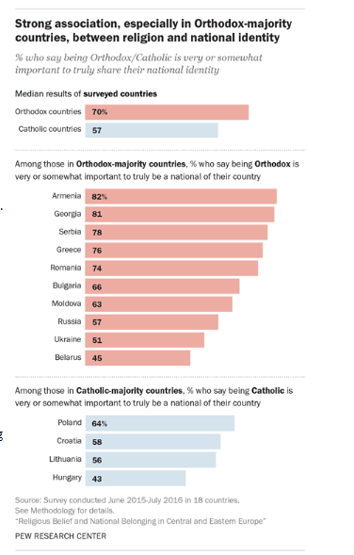
(www.pewforum.org/2017/05/10/religeus-belief-and-national-belonging-in-central-and-eastern-europe/)

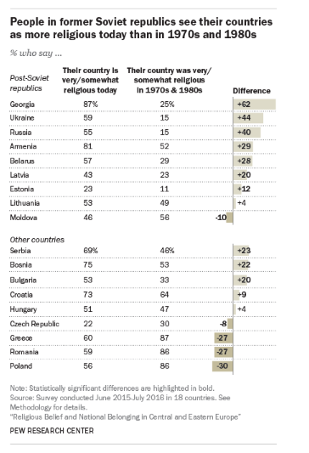
(www.pewforum.org/2017/05/10/religeus-belief-and-national-belonging-in-central-and-eastern-europe/)

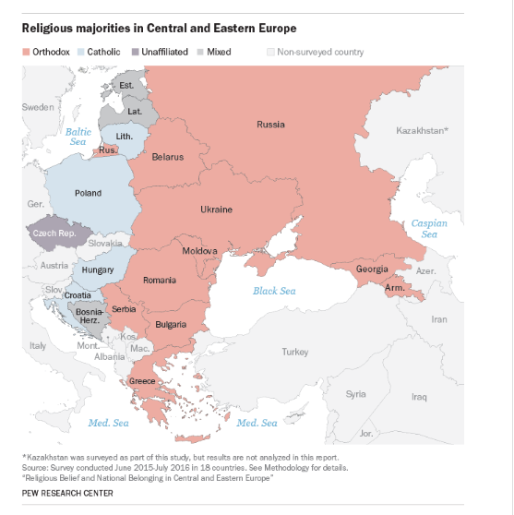
(www.pewforum.org/2017/05/10/religeus-belief-and-national-belonging-in-central-and-eastern-europe/)

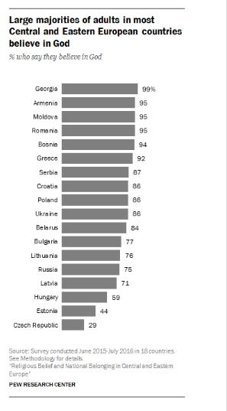
(www.pewforum.org/2017/05/10/religeus-belief-and-national-belonging-in-central-and-eastern-europe/)

6. IMPLICATION FOR SOUTH AFRICA:
The shift of the paradigm from Communism to liberal democracy in Eastern Europe have radical implications for South Africa. The burden of colonialism and apartheid constrained freedom in South Africa until 1994. With the freedom of 1994, a new liberal democracy brought a new paradigm of freedom on all levels. The era of apartheid in South Africa was hugely influenced by a religion of neo-Calvinism that constrained society on every level (Tolmay 2017:145). We may apply this neo-Calvinistic control of society before 1994 with the following quote of Scott Peck (1993:145):
“One of the great sins of organized religion is that it corrupt some very holy words and when people encounter these words, they associate them with the hypocrisy of organized religion and can no longer see or hear their real meaning.”
As religion and faith had a new impulse and vitality in Eastern Europe after communism, the same applied to our situation in South Africa after 1994. Pickering (1984:476) stated that in Durkheim’s view religion will change as society changes. The old religion might die out, but a new religion will be born. This creative process is part of society and human nature.
The decision by South Africa’s apartheid government to release Nelson Mandela in February 1990, changed the face of South Africa. The ban on the African National Congress was revoked and a transition was negotiated to democratic majority rule two months after the fall of the Berlin Wall and the events were intimately connected (Karon et al 2014:2). The Raegan Administration protected the white minority government as a Cold War ally against the ANC who was a friend of Moscow, but with the Cold War winding down, Washington no longer needed its anti-communist allies in Pretoria and F.W. de Klerk read the writing on the wall correctly and opted to negotiate from a position of relative strength, opening a way to a peaceful end to apartheid (Karon et al 2014:3). According to Slabbert (2006:34) a liberal democratic paradigm and market driven paradigm became the basis of the negotiated process for the 1994 democratic elections. The 1996 constitution was based on a liberal democracy in South Africa. The fundamental principles of the liberal democracy have the following implication:
- Everybody is free
- Every person is equal
- Every person have to be treated according to human rights
- A constitutional court was formed to protect these principals and the rule of law
Within this framework is imbedded the freedom of religion. The fall of the Berlin Wall also caused a paradigm shift away from a Neo-Calvinistic paradigm where Afrikaans mainstream churches were the beneficiaries to a new paradigm of equal and free belief participation in society (Tolmay 2017:10).

References:
Aganbegyan, A.G. (ed), 1988, Perestroika Annual, Futura, London.
Beyers, J., 2013, Obituaries and predictions: A sociological perspective on the future of religion, Acta Theologica; Year 33 Vol. No. 1 Junie 2013, University of Free State, Bloemfontein.
Barker, J.A, 1993, Paradigms – The business of Discovering the Future, Harper Business, New York.
Berger, P.L. (Ed), 1999, The Desecularization of the world, The Ethics and Public Policy Centre, Washington.
Bosch, D.J, 2011, Transforming Missions – Paradigm Shifts in the Theology of Missions, Orbis Books, New York.
Borawik, I., 2002, Between orthodoxy and eclecticism: On the religious transformations of Russia, Belarus and Ukraine. Social Compass, 49(4): 497-508.
Castleden, R., 2006, Events that changed the World. Time Warner Books, London.
Corley, F., 1993, The Secret Clergy in Communist Czechoslovakia, Religion, state and Society Vol.21, No 2, 1993.
Erasmus, 2017, Eastern Europe’s patriotic faith, access 30 August 2017 by https://www.economist.com/blogs/erasmus/2017/05/religion-after-communism/
Fallin, V.M., in Aganbegyan, A.G. (ed) 1988, Perestroika Annual, Futura, London.
Karon, K., et al 2014, How the fall of the Berlin Wall changed the world, access 30 August 2017 by http://aljazeera.com/articles/2014/11/9/berlin-wall-25-years.html
Maxwell, R., in Aganbegyan, A.G. (ed) 1988, Perestroika Annual, Futura, London.
New York Times, 2007, Guide to essential knowledge. St. Martin’s Press, New York.
Norris, P., & Inglehart, R., 2011, Sacred and Secular – Religion and Politics Worldwide. Cambridge University Press, Cambridge.
Peck, M.S., 1993, Further along the road less travelled, Simon & Shuster Ltd, London.
Peréz-Nievas, S. & Cordero, G, 2010, Religious Change in Europe (1980 – 2008), Paper at SISP Annual Conference, Venice.
Pew Research Centre, 2017, Religious Belief and national Belonging in Central and Eastern Europe, access 1 August 2017 by http://www.pewforum.org/2017/05/10/religious-belief-and-national-belonging-in-central-and-eastern-europe/.
Pickering, W.S.F., 1984, Durkheim’s sociology of religion: Theses and theories, Routledge, London.
Planyi, M., 1958, Personal Knowledge: Towards a Post-Critical Philosophy. Rootledge & Kegan Paul, London.
Sannikov, S., 1996, Theological Hope in the Post Communist World, http://www.academia.edu/32378641/Theological-hope-in-the-post-communist-world/ access 5 Aug 2017.
Slabbert, FvZ., 2006, The other side of history – An anecdotal reflection om the political transition in South Africa, Jonathan Ball Publishers, Johannesburg.
Sundermeier, T., 1999, Was ist Religion: Religionswissenschaft im theologischen kontext, Gütersloher Verlagshaus, Gütersloh. Eerdmans William B. Publishing Company, Grand Rapids, Michigan
Tolmay, B.J., 2017, Die Toekoms van die Spiritualiteit binne Afrikaner hoofstroomkerke: ‘n Godsdiens-sosiologiese studie, Doktorale Proefskrif, Universiteit van Pretoria, Pretoria.
Tomka, M., 1998, Coping with persecution: Religious change in communism reconstruction in Central Europe. International sociology, 13(2): 229 – 248.
Weber, M., 2003 [1958], The Protestant Ethic and the Spirit of Capitalism, translated by Talcott Parsons, Charles Scribner’s Sons, New York.
http://www.wikipedia.org/wiki/Religion in the Soviet Union access 5 Aug 2017.
http//www.listverse.com/2016/11/13/10 – bizarre ways-the-soviet-union-controlled-its-people access 5 August 2017.
http://www.state.gov>czech republic access 9 August 2017.
U.S. Library of congress, 1994, The Russian Orthodox Church, http:www.country studies.us/Russia/38 htm access 5 August 2017.

